Title of Paper for CIJR
First Author¹, Second Author², Third Author³
¹Designation, Department, Organization, City, Country
²Designation, Department, Organization, City, Country
Abstract— This guide outlines the formatting standards for manuscripts submitted to the IJRIS Journal. Authors should use this file as a reference template and adapt its structure for their own submissions.

Index Terms— List relevant keywords or short phrases in alphabetical order, each separated by commas

Introduction
The manuscript body begins at this point. Insert your content directly into the paragraph fields provided.
Section headings may be duplicated as needed; simply copy the heading and rename it to match the content of your new section.

Guidelines

Subsection
This example illustrates the structure of a subsection. To create additional subsections, duplicate this block and update the heading text accordingly. Subsection numbering updates automatically upon insertion. After pasting, revise the subsection title to suit your content.

Sub Subsection
For sub-subsections, copy the sub-subsection heading above and adjust its title to reflect your content.
Additional sub-points may be added below as needed.
- Numbered list
- Bulleted list
Choose whichever list format best fits your content.

Table
To include a table, paste it into the designated area below and resize either the table or its container as needed. For wide tables, expanding the box allows the content to span a single column.

Figures
To insert a figure, paste it into the template and scale it to the appropriate dimensions for your layout.
Below the figure, include a caption prefixed with "Fig. 1." followed by a descriptive title set at 8 pt font size. A sample figure is provided for reference.

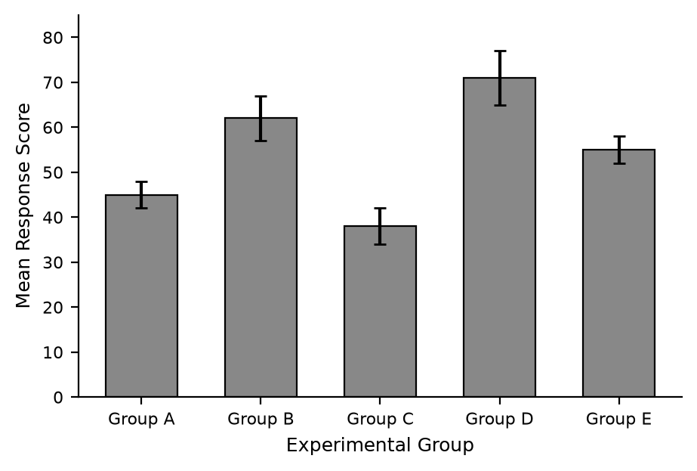
Fig. 1. Sample bar chart showing mean response scores across experimental groups

About references
Reference entries [1] and [2] demonstrate the format for journal articles, [3] and [4] for conference papers, [5] and [6] for textbooks, and [7] and [8] for theses. Any additional source types, such as websites, may follow any of the listed styles.

References
- A. B. Writer, "Title of the article," Name of the Journal, vol. x, no. x, pp. xxx-xxx, Abbrev. Month, year.
- J. U. Duncombe, "Infrared navigation—Part I: An assessment of feasibility," IEEE Trans. Electron Devices, vol. ED-11, no. 1, pp. 34–39, Jan. 1959.
- A. B. Writer, "Title of the paper," in Abbreviated Name of Conf., City of Conf., Abbrev. State (if given), year, pp. xxxxxx.
- D. B. Payne and J. R. Stern, "Wavelength-switched passively coupled single-mode optical network," in Proc. IOOC-ECOC, 1985, pp. 585–590.
- A. B. Writer, "Title of chapter in the book," in Title of His Published Book, xth ed. City of Publisher, Country, USA: Abbrev. of Publisher, year, ch. x, sec. x, pp. xxx–xxx.
- G. O. Young, "Synthetic structure of industrial plastics," in Plastics, 2nd ed., vol. 3, J. Peters, Ed. New York: McGraw-Hill, 1964, pp. 15–64.
- A. B. Writer, "Title of thesis," M.S. thesis, Abbrev. Dept., Abbrev. Univ., City of Univ., Abbrev. State, year.
J. O. Williams, "Narrow-band analyzer," Ph.D. dissertation, Dept. Elect. Eng., Harvard Univ., Cambridge, MA, 1993.

